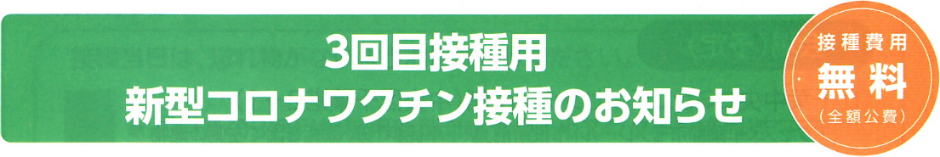
Chiba city: Contents may be changed, so please check the latest situation by the City Home page
Notice on New Corona Vaccination for the third inoculation
Free of Charge

Vaccines that are being inoculated in Japan have a high onset prevention effect and are effective in preventing infection and seriousness has also been confirmed. However, the effect of preventing infection has gradually decreased over time by various research results. Therefore, for prevention of the spread of infection and prevention of serous conditions, we decided to conduct the third inoculation.

1 Target person (those who fall under all of the following conditions)
(1) Those who have received the second corona vaccine
(2) Those who are 18 years of age or older who have a resident card in Chiba City on the day of the inoculation
of the new corona vaccine
※The target person may be reviewed based on further scientific knowledge and the situation of other countries.

2 Starting date of booking
Reservation can be made from the date you receive the enclosed inoculation coupon.

3 When you can receive inoculation
Upon receipt of the inoculation coupon, You can reserve an available inoculation quota and receive an inoculation.
- Please check your "New Corona Vaccine 1, 2nd Vaccination Record" and confirm the the third inoculation date is over 6months from the 2nd inoculation date.
- The timing when inoculation can be received is subject to change depending on the government actions, please check the l \atest situation on the City Homepage etc.
4 Types of vaccines
Regardless of the 1st and 2nd vaccination types, you can receive either vaccines from Pfizer or Takeda/Moderna.
Takeda/Moderna vaccine will become available from February 2022,
5 Method of reservation(you need to make reservation)
Please make a reservation at the medical institution or group inoculation site, where you received 1st and 2nd
Inoculation if possible.
- If you are a medical worker, firstly, check whether you can inoculate at the medical institution where you work.
- If you are inmate or a worker of an elderly facility, please check whether you can inoculate at the facility where you are admitted or working.

Method of individual reservations at medical institutes
➃ （Those who do not fall in ①、②）
Try to find out a medical institution and reserve.
① (Those who want to
receive inoculations at your home Doctors) Contact your home doctor.

or
Telephone
Call Center of chiba city for vaccination
０１２０－５７－８９７０
Open
Mon-Fri 8:30-21:00
Sat/Sun 8:30-18:00

Web
Chiba City Booking site for Vaccination
②（Medical workers）Contact medical institute or facilities you are working.
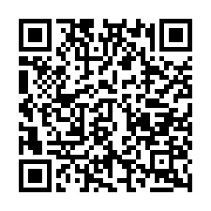

➂ Make reservation in accordance with the method of the institution

※ Please refer to the enclosed list of Medical institutions where you can receive vaccinations.

